**User Guide**

**1 Installation Guidelines**

This MFV system is coding in Java, Blue J and it should be compiled and run in the latest version. Before installing Blue J, please make sure your computer has a proper environment for that as listed below.

Minimum hardware configurations necessary:

Microsoft Windows 8/10:

* + - * Processor: 800MHz Intel Pentium III or equivalent
      * Memory: 512 MB
      * Disk space: 600 MB of free disk space

Macintosh OS X 10.7 Intel:

* + - * Processor: Dual-Core Intel
      * Memory: 2 GB
      * Disk space: 600 MB of free disk space

As computer environment confirmed, please follow these steps to install Blue J. Steps to install Blue J:

1. Please download the latest version of Blue J software and then install it on your computer. ( You can use this website to find the latest version and download. <https://www.bluej.org/versions.html>)

2. In the centre area of the page, select the preferred operating system and the platform.

3. Download the file (size around 195MB).

On OSX

1. Unzip the file, and double-click on “BlueJ”
2. Open MVF system
3. Right click on MFV system class to create a new MFV system by choosing “new MFVsystem()”
4. After creating a new MFV, right click on MFV object to call the method “void mainMenu()” to start the system.
5. Interact with the system through the interface appeared.

On Windows 8/10

1. After the download completes, run the installer.
2. At the Welcome page of the installation, click Next.
3. Click Install to begin the installation.
4. At the Setup Complete page, provide anonymous usage data if desired, and click Finish.

**2 FUNCTIONALITIES**

**2.1 Menu**

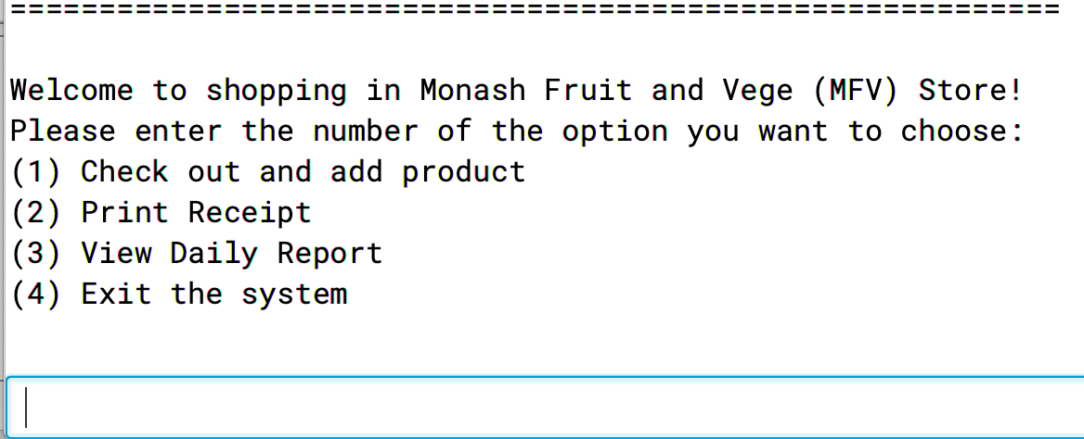

The menu of the MVC system includes all the functions of the system. Users can always switch the interfaces to different section such as print receipt and check out. When users interact with the interface, he/she must follow the instruction of the inputs. For example, the user must use the correct format and input type to other functions. If the user inputs invalid information, then the system will show an error message and ask users to re-enter again.

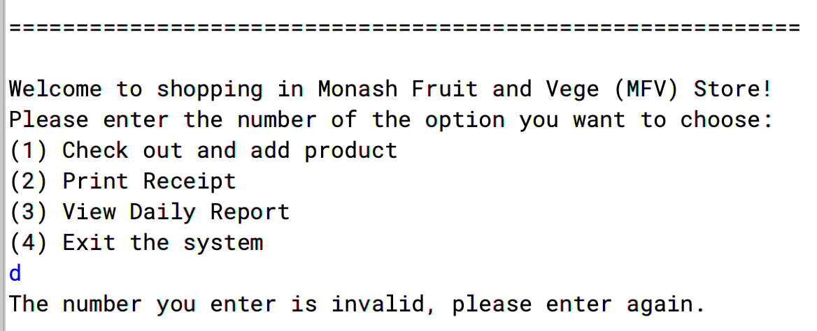

**2.2**

**Check out and add product**

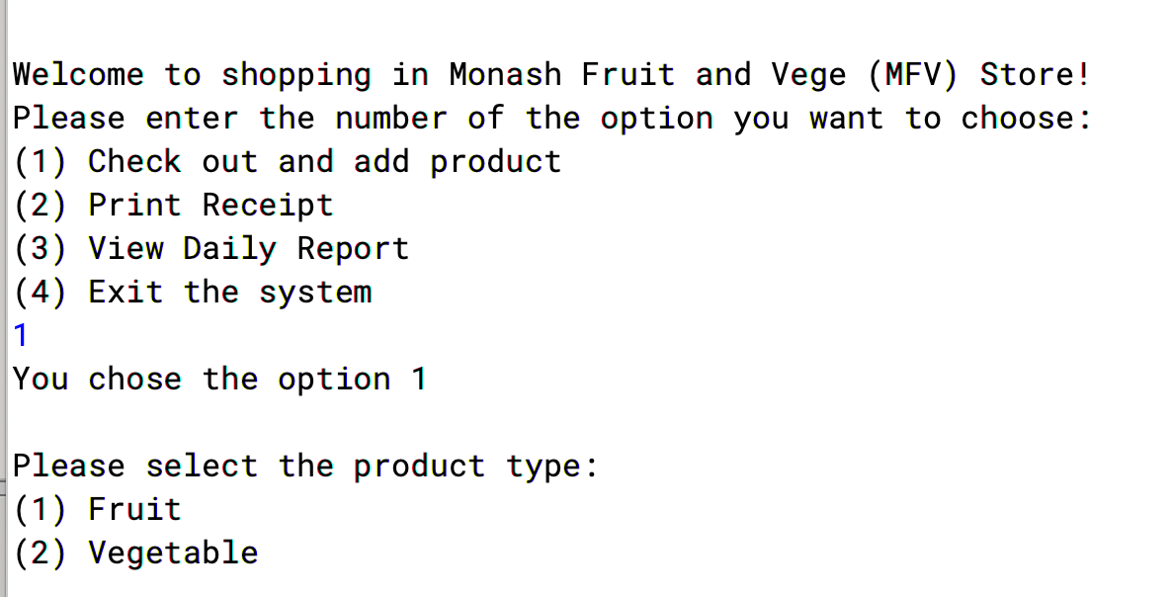

The check out and add product function includes the whole process of shopping on MFV system. In this function, users can select varieties items such as fruits and vegetables. Moreover, users can also choose preferred weighted function. After adding the quantity of items, the system will calculated the price of the shopping cart. The price of this shopping will be stored in the application for future use.

**2.3**

**Print Receipt**

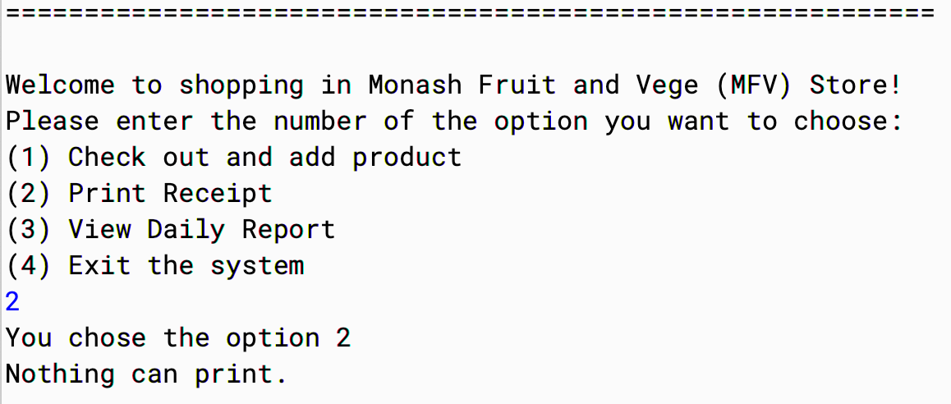

If nothing in the cart and you choose the option 2, it will prompt “Nothing can print”.

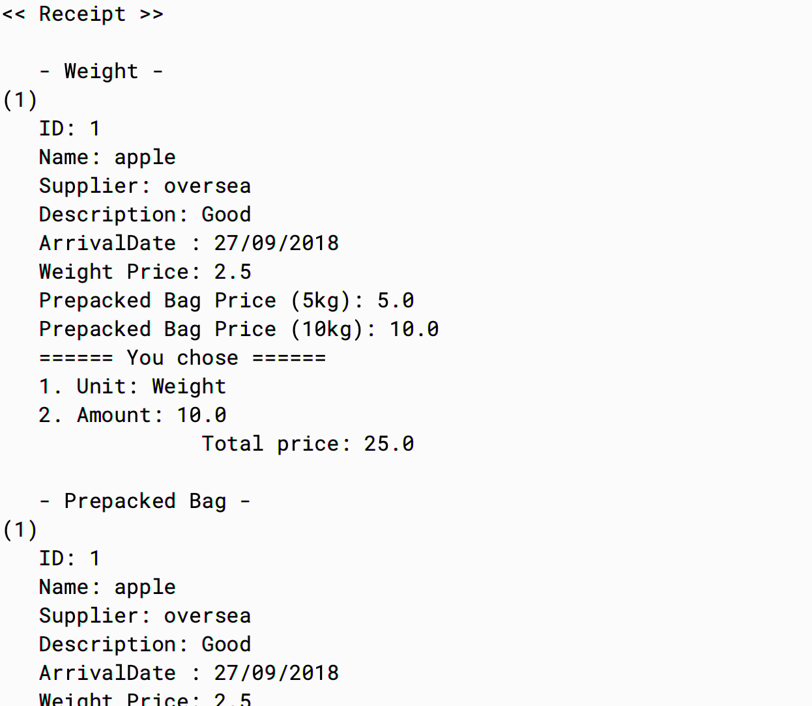

In receipt, it will show you those products whose unit based on the weight firstly, then displaying those based on the bag in the following.

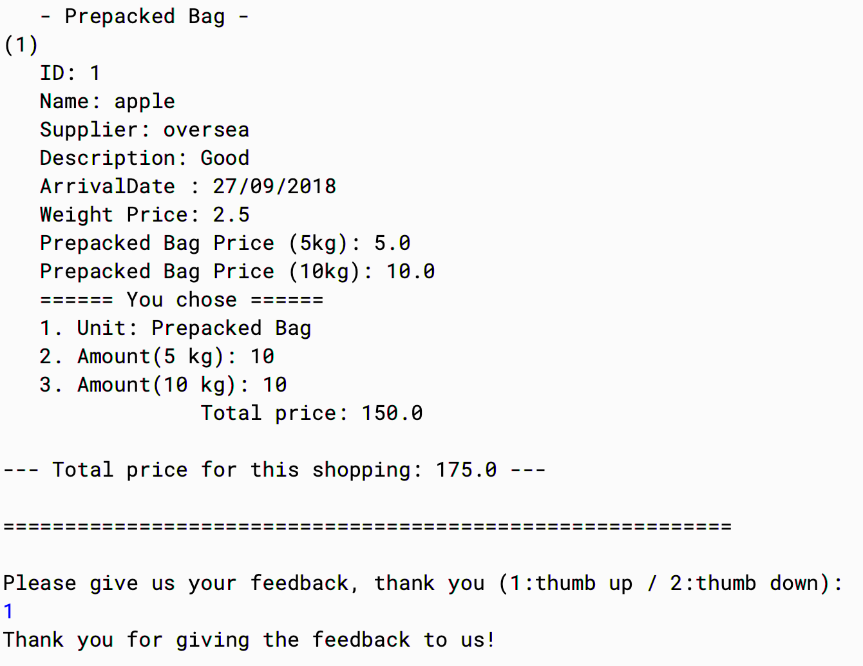

In the end, after showing the total price of this shopping, the system will ask the feedback from you.

After finishing the adding product process, user can choose to print receipt. It will print the detailed information about all the selected products.

Next user can give feedback to the service by inputting 1 or 2(1 represent thumb up and 2 represent thumb down). Then the feedback data will be stored in the application for future use.

If the date expired, it will show how many days expired and the discount of the price. (discount: the shopping date is within 2 days of expiry, then can get 20% off)

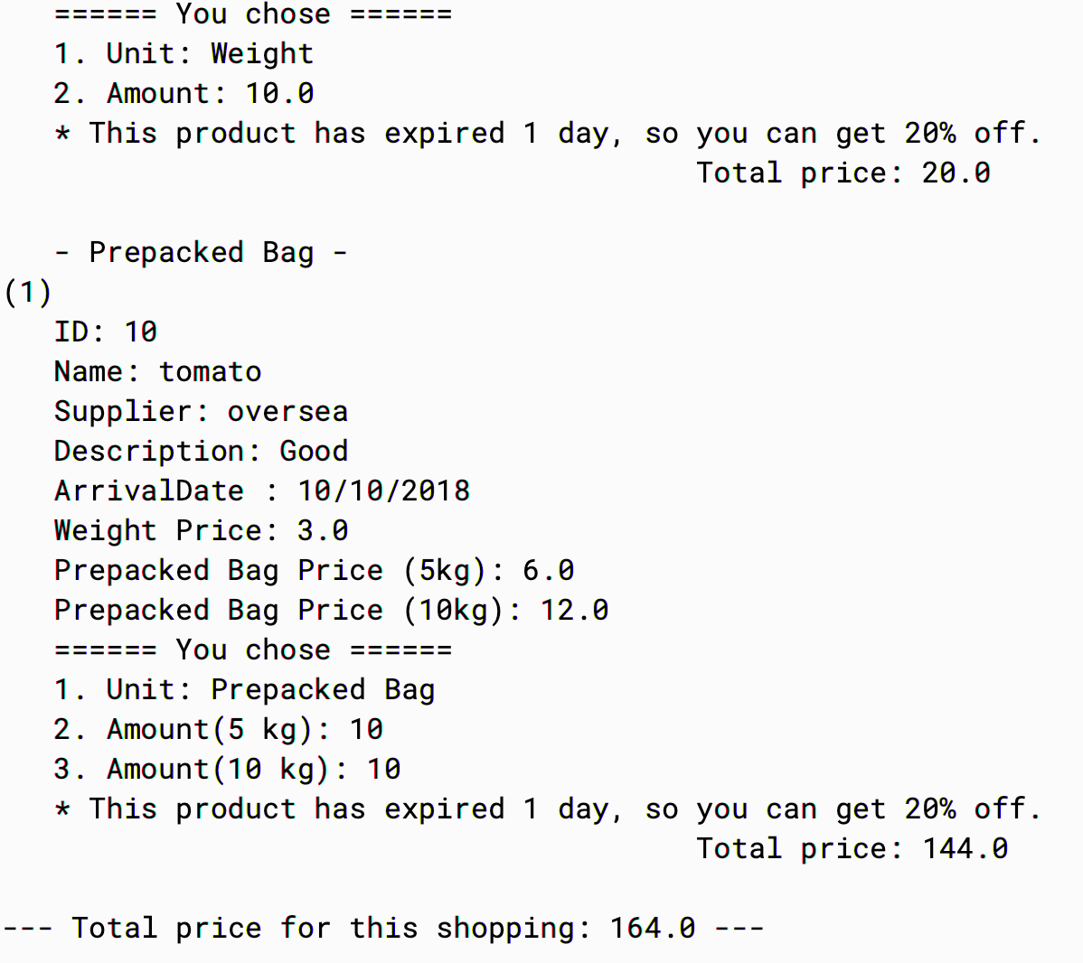

**2.4**

**View Daily Report**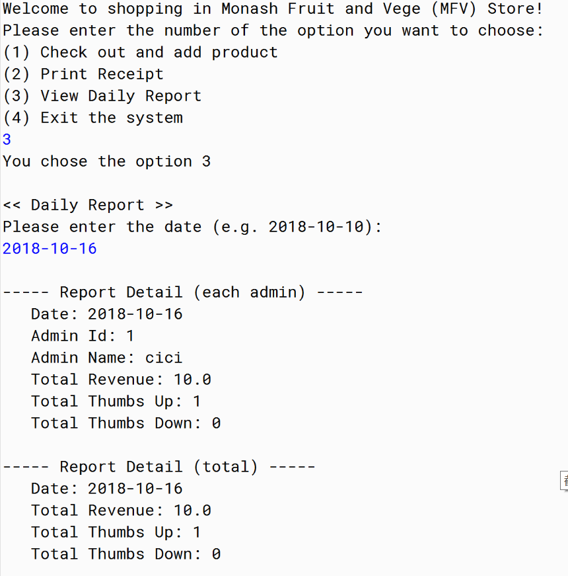

The daily report function shows the information includes date, store admin, store admin's total revenue, total thumb up, total thumb down on a certain day. After input a valid day, the report of the certain day will show on the screen.